Mindfulness Meditation Series, Week #2 Handout
Center for Faculty Development & Advancement, April-May 2021, Jeff Franklin
Definition: “Mindfulness encompasses two components: self-regulation of attention, and adoption of a particular orientation towards one’s experiences. Self-regulation of attention refers to non-elaborative observation and awareness of sensations, thoughts, or feelings from moment to moment. It requires both the ability to anchor one’s attention on what is occurring, and the ability to intentionally switch attention from one aspect of the experience to another. Orientation to experience concerns the kind of attitude that one holds towards one’s experience, specifically an attitude of curiosity, openness, and acceptance. It is worth noting that ‘acceptance’ in the context of mindfulness should not be equated with passivity or resignation. . . .Rather, acceptance in this context refers to the ability to experience events fully, without resorting to either extreme of excessive preoccupation with, or suppression of, the experience. To sum up, current conceptualizations of mindfulness in clinical psychology point to two primary, essential elements of mindfulness: awareness of one’s moment-to-moment experience nonjudgmentally and with acceptance.”
– Shian-Ling Keng, Moria J. Smoski, & Clive J. Robins, “Effects
of Mindfulness on Psychological Health,” Clinical Psychology Review
Mindfulness of Body and Breath Practice Instructions
As the above quote suggests, our goal is to be aware of our body and breathing with an attitude of non-judgment. We start with our body because it is there that our habit energy of attachment to pleasant sensations and aversion to unpleasant sensations is so immediately observable. We practice being non-attached and non-aversive in relation to our bodily sensations as a step toward practicing this same kind of non-judgmentalness toward our emotions and our thoughts, as we will practice in the coming weeks. And, as always, the breathing is our anchor in and to our body, emotions, and thoughts.
- Finding a comfortable seated position, both relaxed and naturally uplifted, lifting your heart, a natural curve in your lower back, shoulders dropped, ears over shoulders, jaw relaxed, tongue resting on the roof of the mouth.
- Begin by tuning in to your body, feeling the body’s sensations directly as physical, tactile experiences, noting each point of the body that is touching something other than yourself, being specific in what sensations are there.
- Then scanning your body as a whole, simply feeling any overall sensation, such as sleepiness or energy, warmth or coolness, tightness or looseness, whatever you’re feeling, just as it is.
- Setting the intention to stay with the body, to resist going off into a story or self-judgment, just being in the body in the present moment, breathing, resting but aware. If you have an itch, consider making that the object of meditation. If there is physical discomfort or mild pain, try inviting yourself to breathe into that area with non-reactive but caring awareness, following your breathing, or of course you may mindfully change positions as needed.
- If focusing on the body becomes triggering for you, empower yourself to rise out of the practice, open your eyes, and self-regulate, breathing deeply and slowly as needed.
- Coming to focus especially on the breathing, the physical sensation of air flowing in and flowing out, feeling the coolness at the nostrils or the rising and falling of the chest or the belly, like waves on a sunny beach, rolling in, rolling out.
- When your mind wanders into reliving the past or planning the future, as is very common, or if you get swept away by a feeling or a thought, gently guiding your attention back to the body, back to the steady, comforting rhythm of the breathing, with a gentle non-judgmental tone.
- As you move toward wrapping up, consider inviting yourself to savor the calmness and sense of well-being in the body at the present moment.
The invitation of the homework is to practice the above for about 7 minutes per day. If you find it challenging to remember or commit, try putting it on your phone clock or Outlook calendar for the same time each day. For me, this makes it easier to skip the “do I feel like it right now?” step and go straight to what I know I’ve already decided and just do it. Here is a link to me leading this practice.

“Don’t meditate to fix yourself, to improve yourself, to redeem yourself; rather, do it as an act of love, of deep warm friendship to yourself. In this way there is no longer any need for the subtle aggression of self-improvement, for the endless guilt of not doing enough. It offers the possibility of an end to the ceaseless round of trying so hard that wraps so many people’s lives in a knot. Instead there is now meditation as an act of love. How endlessly delightful and encouraging.” – Bob Sharples, “Meditation: Calming the Mind (excerpt)”

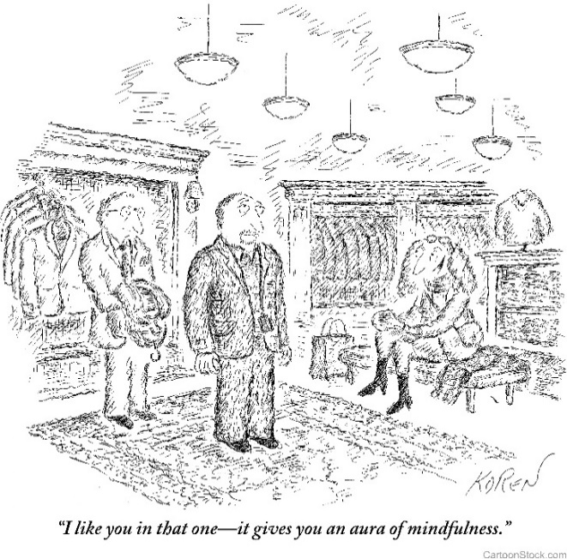

KEEPING QUIET, by Pablo Neruda (1904-1973)
Now we will count to twelve
and we will all keep still.
For once on the face of the earth,
let’s not speak in any language;
let’s stop for one second,
and not move our arms so much.
It would be an exotic moment
without rush, without engines;
we would all be together
in a sudden strangeness.
Fisherman in the cold sea
would not harm whales
and the man gathering salt
would look at his hurt hands.
Those who prepare green wars,
wars with gas, wars with fire,
victories with no survivors,

would put on clean clothes
and walk about with their brothers
in the shade, doing nothing.
What I want should not be confused
with total inactivity.
Life is what it is about;
I want no truck with death.
If we were not so single-minded
about keeping our lives moving,
and for once could do nothing,
perhaps a huge silence
might interrupt this sadness
of never understanding ourselves
and of threatening ourselves with death.
Perhaps the earth can teach us
as when everything seems dead
and later proves to be alive.
Now I’ll count up to twelve
and you keep quiet and I will go.

