Mindfulness Meditation Series, Week #4 Handout
Center for Faculty Development & Advancement, April-May 2021, Jeff Franklin
Definitions: “Mindfulness is present-time awareness. It takes place in the here and now. It is the observance of what is happening right now, in the present moment. It stays forever in the present, perpetually on the crest of the ongoing wave of passing time. If you are remembering your second-grade teacher, that is memory. When you then become aware that you are remembering your second-grade teacher, that is mindfulness. If you then conceptualize the process and say to yourself, ‘Oh, I am remembering,’ that is thinking.” – Henepola Gunaratana, Mindfulness in Plain English
“Mindfulness is the ability to know what’s happening in your head at any given moment without getting carried away by it.” – Dan Harris & Katy Davis “Why Mindfulness is a Superpower: An Animation” check this out online

Mindfulness of Thoughts Practice Instructions
Continuing from last week’s focus on mindfulness of emotions, this week we focus on mindfulness of thoughts, noticing when we are thinking, in contrast to being “lost in thought” or daydreaming, and observing those thoughts as whatever they are from outside of them, rather than being immersed in the thoughts such that we feel that they constitute our present-moment reality.
- Finding a comfortable seated position, relaxed and naturally dignified, lifting your heart alittle, a natural curve in the lower back, shoulders released downward and ears aligned with shoulders, jaw relaxed, tongue resting on the roof of the mouth.
- Begin by tuning in to your body and your breathing, following the introductory steps of the “Mindfulness of Body and Breath Practice Instructions” from a prior week, just spending a minute or two settling in, arriving in your body in the present moment, and following the breathing.
- Gently turning your attention to whatever thoughts are present, whether many or few, slow or rapid, not trying to stop or control the thoughts, just letting them come and letting them go, because that’s just what the mind does.
- Watching a thought like watching a bird fly across an expanse of blue sky: it appears, crosses your field of vision, then disappears. There that is; there that goes.
- If you find you’ve wandered into a storyline or gotten caught up in a train of thought, gently label it “thinking,” in a kind tone of internal voice, and return to the steady rhythm of the breathing, like the surface of the ocean on a calm day.
- And, recommence being aware of thoughts as they arise and pass away, no need for any response or action on your part, just watching then releasing the thoughts.
- When you choose to draw the practice to a close, check in to your state of mind in the current moment, and, if you find it relatively quiet and smooth, observe that as just another thought, and maybe smile to yourself with acceptance.
The invitation of the homework is to practice the above for about 10 minutes per day, ideally scheduled for the same quiet time and comfortable place each day. You can access a video of me leading this meditation at this link.
“By consciously observing the workings of our mind, we are able gradually to let go of its habitual, programmed interpretations and automatic reactions. Reflection on the addicted brain, not willful resistance to it, is the way to tame it. . . .Brain research is demonstrating that mindful awareness is able to release the grip of harmful thoughts and also to change positively the physiology of the brain circuits where those thoughts originate. The implications for the healing of addiction are far-reaching. We can distinguish between two kinds of mind function: awareness (the dispassionate observer) and the jumble of automatic processes (conscious, semiconscious, and subconscious) that dictate our emotional states, thoughts, and much of our behavior.” – Gabor Mate, In the Realm of Hungry Ghosts: Close Encounters with Addiction

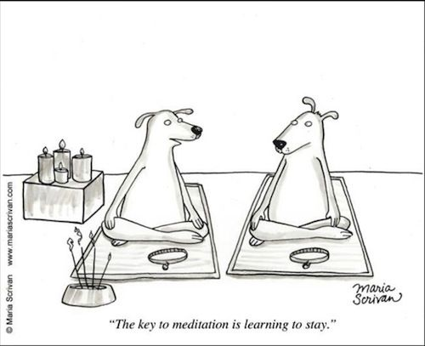

PARADOX OF NOISE, by Gunilla Norris
It is a paradox that we encounter so much internal noise
when we first try to sit in silence.

It is a paradox that experiencing pain releases pain.
It is a paradox that keeping still can lead us
so fully into life and being.

Our minds do not like paradoxes. We want things
To be clear, so we can maintain our illusions of safety.
Certainty breeds tremendous smugness.

We each possess a deeper level of being, however,

which loves paradox. It knows that summer is already

Growing like a seed in the depth of winter. It knows
that the moment we are born, we begin to die. It knows
that all of life shimmers, in shades of becoming—
that shadow and light are always together,
the visible mingled with the invisible.

When we sit in stillness we are profoundly active.
Keeping silent, we hear the roar of existence.
Through our willingness to be the one we are,
We become one with everything.

