Mindfulness Meditation Series, Week #3 Handout
Center for Faculty Development & Advancement, April-May 2021, Jeff Franklin
Definitions: “Mindfulness is the awareness and nonjudgmental acceptance by a clear, calm mind of one’s moment-to-moment experience without either pursuing the experience or pushing it away.” – N. Singh et al., “Adolescents with Conduct Disorder Can Be Mindful of Their Aggressive Behavior”
“Mindfulness means allowing careful, compassionate responses to develop in response to the flow of your life experiences.” – Thomas Roberts, The Mindfulness Workbook
Mindfulness of Emotions Practice Instructions
Continuing from last week’s focus on body and breathing, this week we focus on mindfulness of emotions, sitting with whatever emotions arise without attachment or aversion to them, without identifying with them—though real experiences, they are not me, and I am not determined by them.
- Finding a comfortable seated position, both relaxed and naturally dignified, lifting your heart, a natural lower-back curve, shoulders dropped, ears over shoulders, jaw relaxed, tongue resting on the roof of the mouth, eyes closed or with a softened and lowered gaze.
- Begin by tuning in to your body and your breath, following the introductory steps of the “Mindfulness of Body and Breath Practice Instructions” from last week, or just spending a few minutes settling in, arriving in your body in the present moment, and following the breathing.
- Gently shifting your awareness to any emotions you are feeling. What are you feeling? Noticing whatever emotion arises, being willing to be present with it. Giving yourself permission to accept any emotion just as it is.
- Like sitting on the bank of a river watching different boats float by, some beckoning you to jump aboard, some frightening or repelling to you, but you choose to sit quietly, without attachment or aversion, just observing as they float past without needing to get on or to fend off.
- If you get swept away by an emotion or find yourself pushing one away, gently guide yourself back to the refuge of the current moment and the steady, comforting rhythm of the breathing.
- If an emotion becomes too intense or triggering, empower yourself to back out of the practice, open your eyes, and begin self-regulating with slow, steady breathing. Take care of yourself.
- Then, if you are able, return to just seeing the emotions arise and pass without getting reactive. You are not the emotions, and they do not determine who you are.
- When you choose to draw the practice to a close, check in to your emotional state in the current moment, enjoying whatever degree of peacefulness and stability that is present for you.
The invitation of the homework is to practice the above for around 10 minutes per day, ideally scheduled for the same quiet time and comfortable place each day. You can access a video of me leading this meditation at this link.
For reflection: “Much of the time, it turns out, everyday minds are in a state of reactivity. We take this for granted, we do not question our automatic identifications with our reactions, and we experience ourselves at the mercy of an often hostile or frustrating outer world or an overwhelming or frightening inner one. With bare attention, we move from this automatic identification with our fear or frustration to a vantage point from which the fear or frustration are attended to with the same dispassionate interest as anything else. There is enormous freedom to be gained from such a shift. Instead of running from difficult emotions (or hanging on to enticing ones), the practitioner of bare attention becomes able to contain any reaction: making space for it, but not completely identifying with it. Given that addiction is all about running from difficult emotions or hanging on to enticing ones, bare attention has the potential to dissolve the very motivations that drive the addicted mind.” – Gabor Mate, In the Realm of Hungry Ghosts: Close Encounters with Addiction

Two multiple-choice questions, your preference for A. or B. in each?—there are no wrong answers:
- or B.
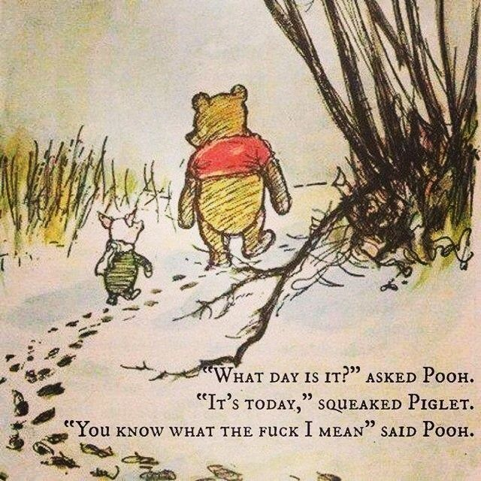

- or
The Summer Day, by Mary Oliver

Who made the world?
Who made the swan, and the black bear?
Who made the grasshopper?
This grasshopper, I mean—
the one who has flung herself out of the grass,
the one who is eating sugar out of my hand,
who is moving her jaws back and forth instead of up and down—
who is gazing around with her enormous and complicated eyes.
Now she lifts her pale forearms and thoroughly washes her face.
Now she snaps her wings open, and floats away.
I don't know exactly what a prayer is.
I do know how to pay attention, how to fall down
into the grass, how to kneel down in the grass,
how to be idle and blessed, how to stroll through the fields,
which is what I have been doing all day.
Tell me, what else should I have done?
Doesn't everything die at last, and too soon?
Tell me, what is it you plan to do
with your one wild and precious life?
B.
THE GUEST HOUSE, by Rumi (1207-1273)
(Translation by Coleman Barks)
This being human is a guest house.
Every morning a new arrival.
A joy, a depression, a meanness,
some momentary awareness comes
as an unexpected visitor.
Welcome and entertain them all!
Even if they’re a crowd of sorrows,
who violently sweep your house
empty of its furniture,
still, treat each guest honorably.
He may be clearing you out
for some new delight.
The dark thought, the shame, the malice.
Meet them at the door laughing and invite them in.
Be grateful for whatever comes.
Because each has been sent
as a guide from beyond.

